Fleet Maintenance Strategy 2026–2030
Asset Operations
David Chen · 30 June 2026 · OPS-STR-0002

1. Purpose
This strategy sets out how Weyland maintains its operating fleet of 13 assets (1,100 MW of onshore wind and solar PV in the UK, Germany and Denmark) between 2026 and 2030, and how we prepare for Harrow Bay Offshore Wind (480 MW, COD planned 30 June 2028). It replaces the 2023 strategy and takes into account the lessons from the Kestrel Ridge T-07 gearbox failure.

2. Principles
- Safety first – no maintenance task is so urgent that it cannot be done safely.
- Condition-based where it pays – drive trains, blades, transformers and inverters are maintained on condition; everything else on fixed intervals.
- Own the data – SCADA, CMS and oil analysis data belong to Weyland, regardless of the service contract.
- Right contract model for the asset age – full service during warranty, then a deliberate choice between OEM, ISP and self-perform.
- Fleet learning – every major failure triggers a fleet-wide check within 30 days.

3. Contract models by asset
Asset | Age (2026) | Current model | Decision point | Preferred next model
Kestrel Ridge | 2 | Full service – Highline Wind Services | 2034 (end of term) | Extend or ISP
Skerrow Moor | 10 | Full service – OEM | 2027-12 | ISP with major component insurance
Dunmore Hill | 12 | Self-perform + specialist | – | Self-perform; repowering study 2028
Glenquey | 7 | Full service – OEM | 2029-06 | Retender
German wind (5 parks, 520 MW) | 5–11 | OEM / self-perform | 2027–2030 | Bundle German wind into one ISP tender
Thy Vest | 8 | Full service – OEM | 2028-03 | OEM extension (good performance)
Ringkøbing | 13 | Self-perform + specialist | – | Repowering study 2027
Solar PV (Uckermark, Lüneburger Heide) | 4–6 | O&M contractor | rolling | Regional O&M framework Germany
Harrow Bay (from 2028) | – | OEM warranty-period service (Halden) | 2033 | See Harrow Bay O&M readiness plan

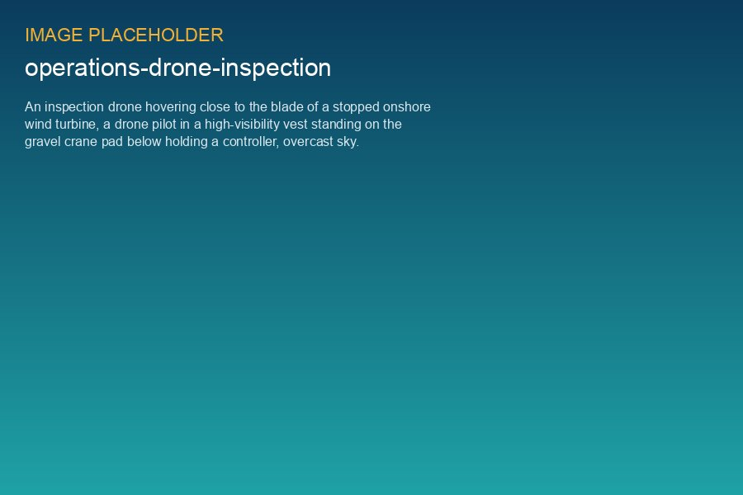
Drone blade inspection at Kestrel Ridge, August 2026

4. Wind: drive train and blades
All wind turbines will have vibration CMS with Weyland-owned thresholds by the end of 2026. After the T-07 failure we lowered the kurtosis alarm threshold for ISS bearings from 4.5 to 3.8 and added an escalation rule: any 'watch' oil result triggers an endoscope inspection within four weeks. Oil is sampled every three months on all gearboxes older than one year.
Blades are inspected by drone every year and by rope access every three years. Leading edge erosion of Category 3 or worse is repaired in the following summer; we budget EUR 3,300 per blade per year for leading edge protection across the fleet.

5. Solar and storage
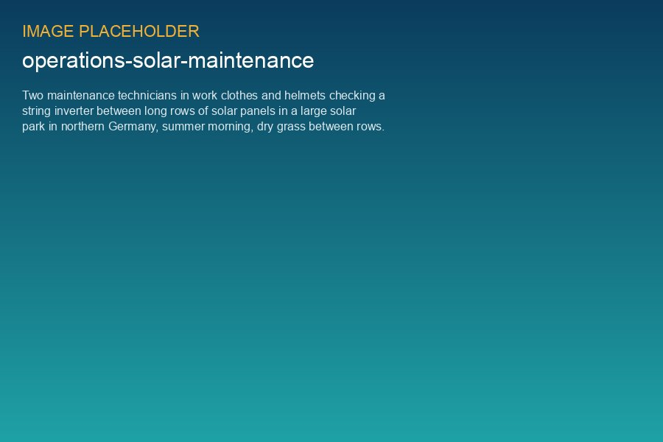
Inverter inspection at Uckermark Solarpark
For the solar parks the main availability drivers are central inverters and medium-voltage stations. We keep one spare inverter power stack per park type and one spare MV transformer for the German parks. Module cleaning is done only where soiling losses exceed 2 % (currently none). Thermography by drone is done annually in June.
Battery storage will join the fleet with Millbrook Solar & Storage and Fenwick Battery Storage. Asset Operations is involved in the design reviews to secure Weyland-owned BMS data, a long-term service agreement with the integrator, and remote monitoring from the Edinburgh control centre from day one.

6. KPIs
KPI | 2025 actual | Target 2026 | Target 2030
Wind time-based availability | 97.1 % | 97.0 % | 97.5 %
Solar availability | 99.4 % | 99.3 % | 99.5 %
Unplanned major component exchanges per 100 turbines | 1.4 | < 1.5 | < 1.0
OPEX wind (EUR k/MW/yr) | 58.4 | 59.0 | 55.0
Corrective work orders closed within 14 days | 79 % | 85 % | 92 %

7. Roadmap
Year | Milestones
2026 | CMS thresholds owned by Weyland on all assets; fleet spare parts system live; T-07 lessons rolled out
2027 | German wind ISP tender; Harrow Bay control room integration; blade LEP campaign at Kestrel Ridge
2028 | Harrow Bay COD and O&M base at Port of Eastholm; Skerrow Moor contract switch
2029 | Dunmore Hill and Ringkøbing repowering decisions; first BESS in operation (subject to consent)
2030 | Review of Harrow Bay service model ahead of warranty expiry

